Scope of Work

## Developer Name

Daniel Cook

## Date

08/19/2020

## Gitrepo or source files

* Back End: <https://github.com/dmc3152/iot-be>
* User Interface: <https://github.com/dmc3152/iot-ui>
* Summer Practicum Repository: <https://github.com/dmc3152/summer-practicum>

## Title

IoT Monitor

## Design Concept

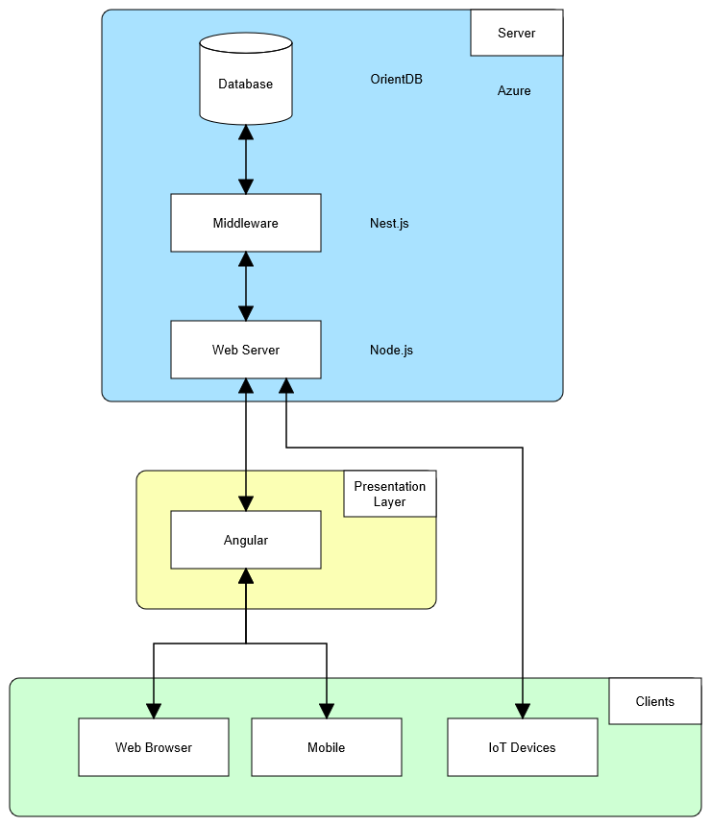

## Some Requirements, Foundations and Features

* Users can have individual accounts
  + Accounts must be secure
* Users can enter custom data schemas for their devices
* Users can view data visualizations
* Devices can publish data to the system

## Planning/Stages

* Research database technologies
* Research API technologies
* Build database prototype
* Build API prototype
* Build user interface prototype
* Integrate prototypes together into application
* Start project database
* Start project API server
* Start project user interface
* Build user authentication system
* Add guards to API endpoints
* Add guards to user interface routes
* Migrate application to the cloud
* Design database data structure
* Build API services and endpoints
* Build Data Schema feature
* Build Device feature
* Build IoT device data services and endpoints
* Build Reporting feature

## Deliverables/Milestones

* Prototype Application
* Basic Application
* User Authentication
* Cloud Migration
* Data Schema Feature
* Device Feature
* Reporting Feature

## Status

Version 1.0 Complete